Git Setup with Visual Studio 2019

1. Open Visual Studio with Admin Rights
2. Open Team Explorer from View Menu
3. Click on Manage Connections icon

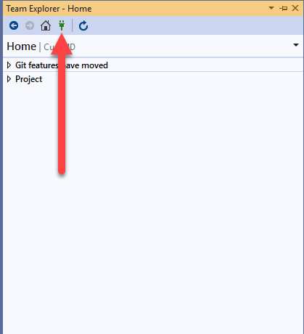

1. Click on Manage Connections dropdown and then **Connect to a Project…**

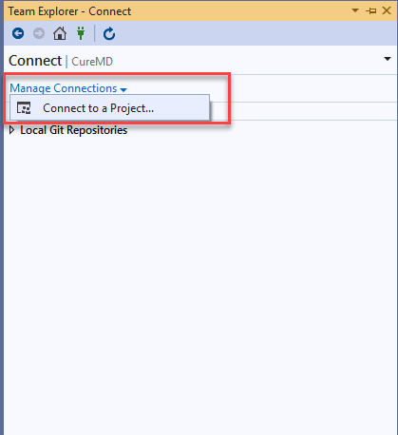

1. Enter server URL: [**http://cmdlhrdevops/**](http://cmdlhrdevops/)and Click on Add

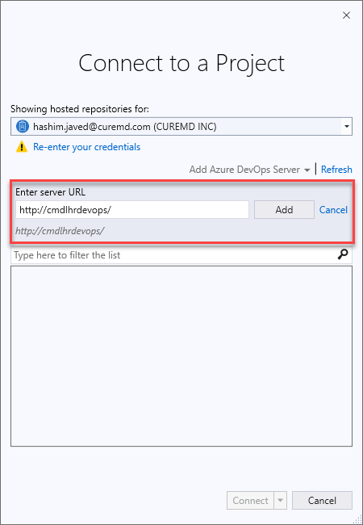

1. Find the Repository with your Employee ID & Name and Browse the Path to C:\Users\hashim.javed\Desktop\Repos

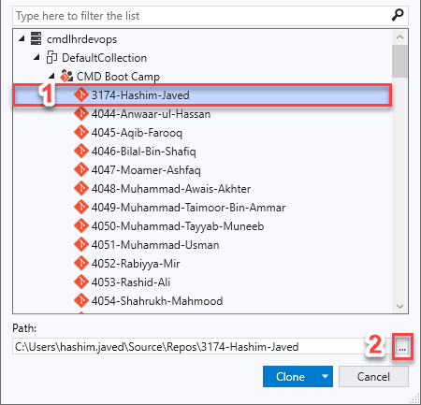

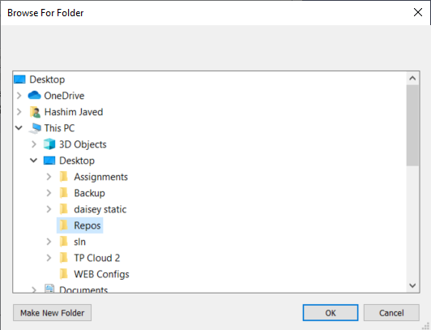

1. Click on the Clone Button

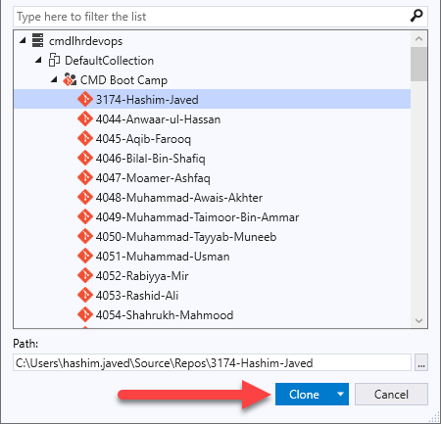

**Branch Creation, First Commit and Push Changes**

1. Open Git Changes from View Menu
2. Open File Explorer and Navigate to the ~/Desktop/Repos
3. Place the **.gitignore** file inside the folder

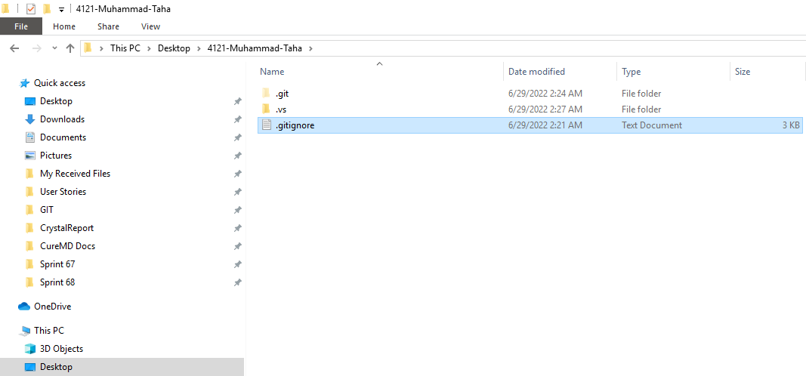

1. Go back to the Visual Studio and Open Git Changes
2. Click on the **PLUS (+)** icon against the .gitignore file

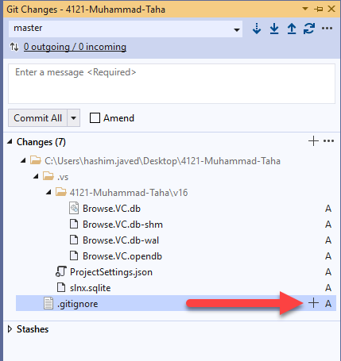

1. The file will appear in the **Staged Changes** tab

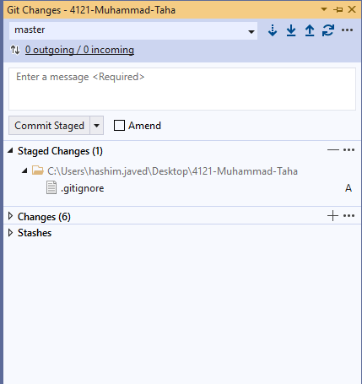

1. Type **First Commit** in the text area and Click on the **Commit Staged**

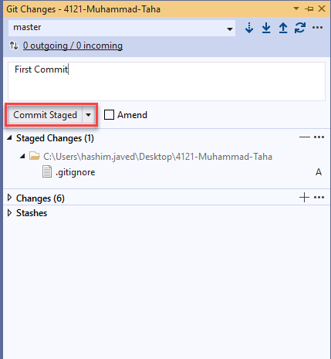

1. You will receive this message which means your commit is successfully created

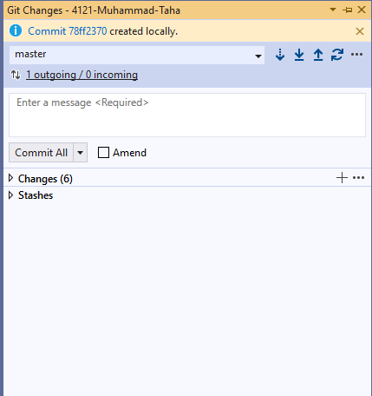

1. Click the **Push** icon and you will receive the success message

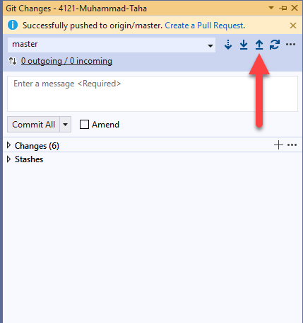

1. Open the DevOps URL: <http://cmdlhrdevops/DefaultCollection/_git/CMD%20Boot%20Camp>
2. Find your Repository my searching with your name

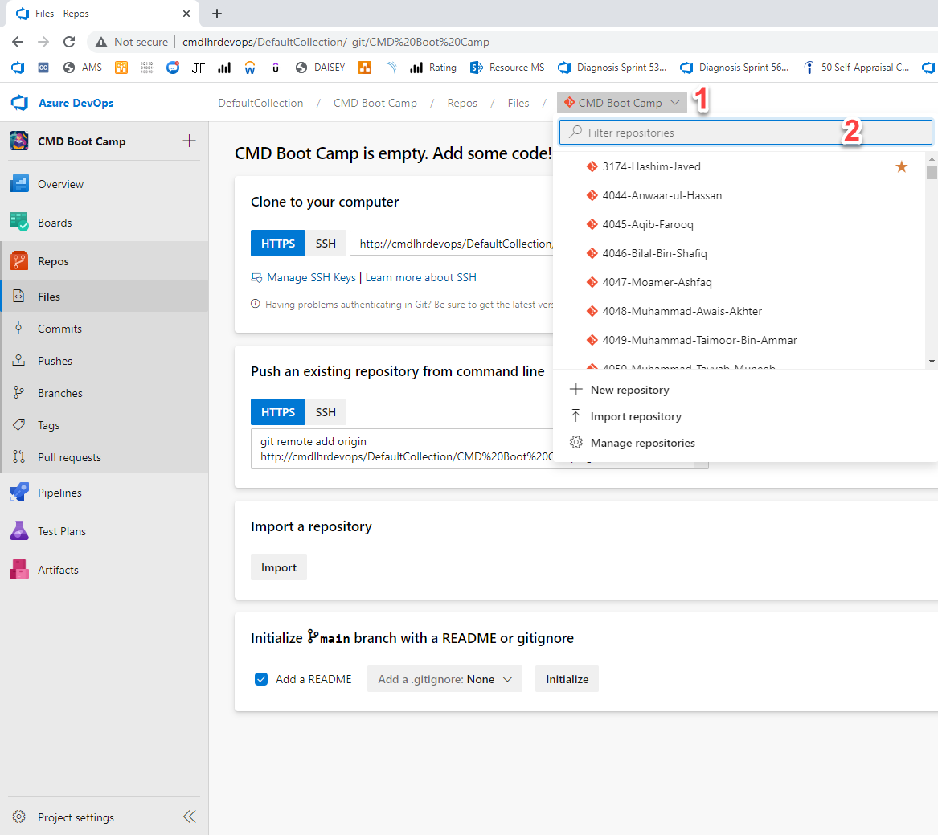

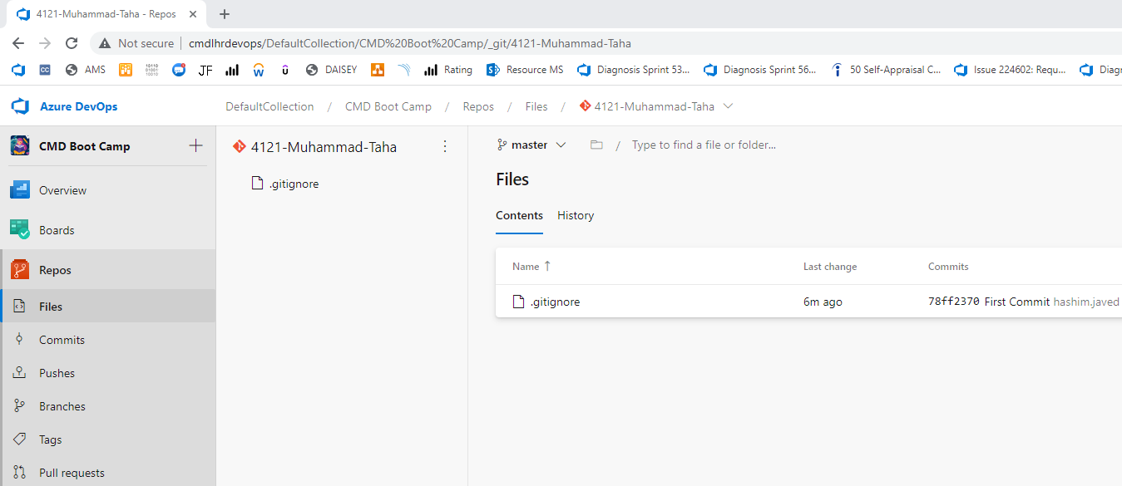

1. Click on branch name **master** and click on **New branch**

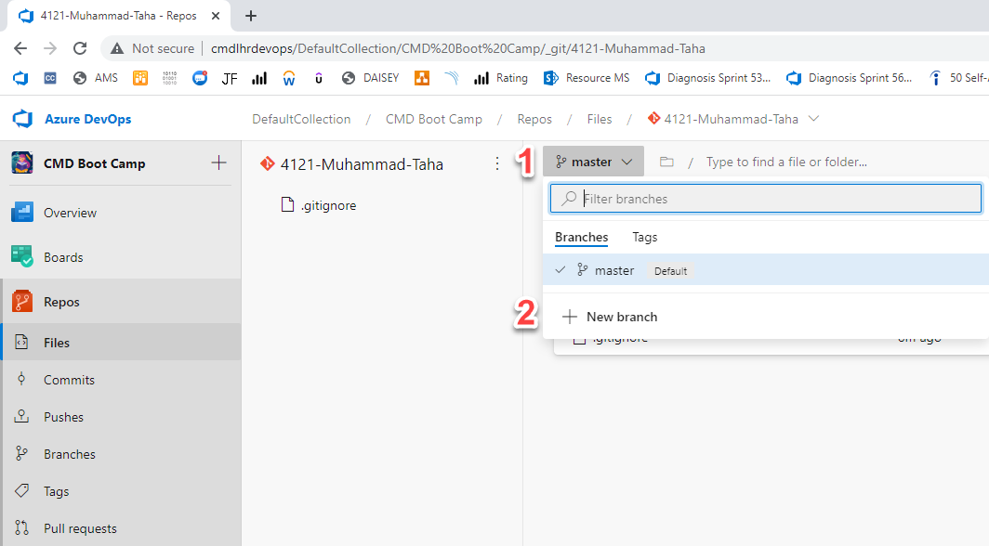

1. Write the name of the branch like **PF-Assignment-01** in the *Name\** field and make sure that **master** is select in the *Based on* field then click on **Create**

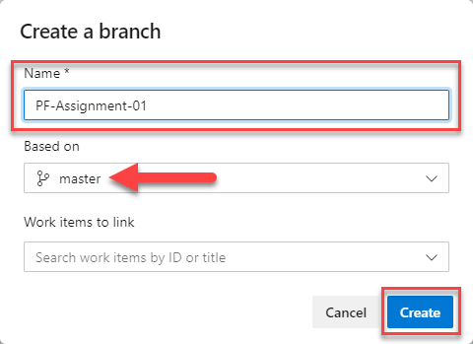

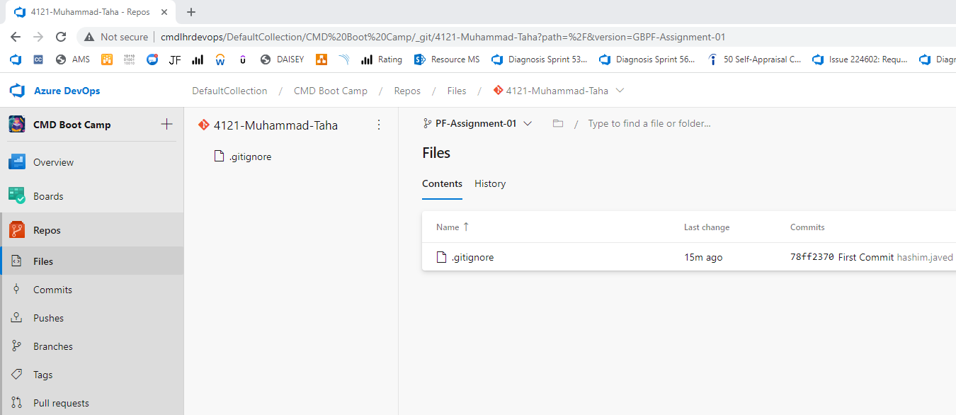

1. Go back to the Visual Studio and Open Git Changes and Click on **Fetch** icon

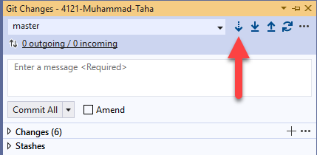

1. Click on the branch name on the right bottom corner of the Git Changes panel

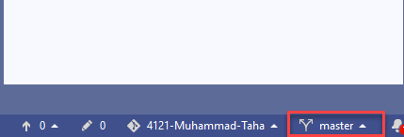

1. From the popup window, select the Remotes tab and Click on your branch name

e.g. *origin/PF-Assignment-01*

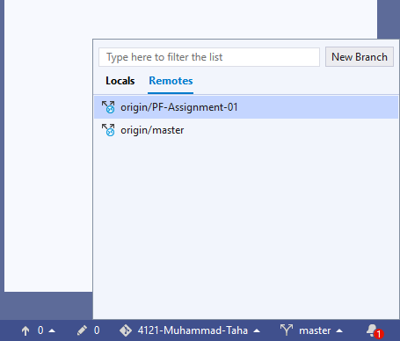

1. Your branch will be checked-out

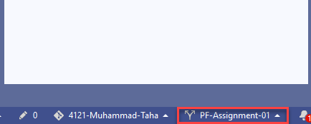

1. Now repeat the above steps to Commit and Push your First Assignment Files in the newly created branch (see below)
2. Place your **\*.cs** or **\*.cpp** files inside the folder ~/Desktop/Repos

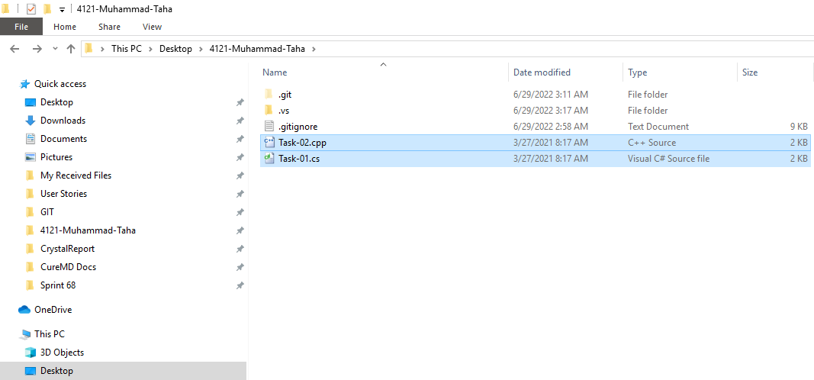

1. Go back to the Visual Studio and Open Git Changes
2. Click on the **PLUS (+)** icon against only your files and repeat from Step #6

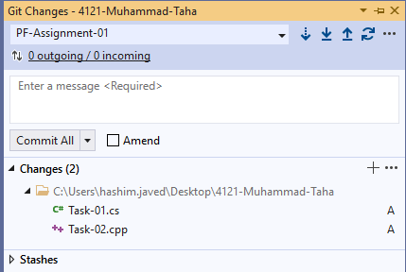

**Commit | Push | Repeat**